**STUDENT NUMBER: ST10475262**

**NAME: Boikanyo Dimpho**

**MODULE NAME: WEB DEVELOPMENT**

**MODULE CODE: WEDE5020**

**WEBSITE PROPOSAL**

**Kagoyarona Scents**

Kagoyarona Scents is a small and independent business launched in 2022 by scent enthusiast and comfort lover Onkarabile Boikanyo. Focusing more on reed diffusers, car scents and scented candles, Kagoyarona Scents specializes in providing vegan, long lasting eco-friendly scents that will elevate your mood.

The **mission statement** is to provide affordable high-quality scents that make everyday life feel calm and luxurious without having to compromise on quality.

The **vision statement** is to become a go-to website for scents that are affordable and feel luxurious.

The **target market** for Kagoyarona Scents is anyone who is interested in existing in a space that caters to their desired scent. it is also marketed towards anyone who would like to gift a loved one something special as well as bulk buyers who order for events.

**Website Goals and Objectives:**

**Website Goal:**

■ Increase online sales by 40% within six months.

**Objectives:**

■ Improve brand awareness through SEO and social media integration.

■ Provide an intuitive e-commerce experience with seamless checkout.

**Current website analysis:**

Kagoyarona Scents does not have a fully-fledged website, but they do have an online presence through social media. They have an Instagram account, Facebook account as well as a TikTok account. For a new business, they have garnered a decent number of followers and viewers across all platforms.

The **disadvantages** that come with using social media as a website include:

**Algorithm dependency:**

* Being dependent on the application’s algorithm. The visibility of the profile is determined by the algorithm, which can prevent even the most loyal followers from seeing your profile.

**Poor discoverability:**

* Without a website, the chances of being discovered are slim. Many people turn to Google to find websites for their needs. This means they miss out on generating traffic.

The **advantages** of having a website are:

Enhanced Credibility & Professionalism:

 A custom domain (www.kagoyaronascents.co.za) signals legitimacy and establishes trust, making customers more confident in purchasing from you.

**Proposed Website Features & Functionality:**

* Homepage: Hero banner with seasonal promotions.
* Product Pages: display all scents (floral, woody, fresh), with high-quality images.
* About Us: Founder’s story and sustainability commitment.
* Contact Us: includes the founder's social media pages and the businesses social media accounts
* Enquiries: allows submissions for fragrance suggestions and any problems enquired
* Blog: "Scent Tips" for home fragrance enthusiasts.

**Design & User Experience:**

* Colour Scheme: Soft neutrals (ivory, peach, blush pink).
* Typography: Serif (Playfair Display) for headings, sans-serif (Montserrat) for body text.
* Layout: Clean, minimalist with intuitive navigation.

**Technical Requirements:**

* Hosting:

-hostafrica for a more affordable option

* Domain: www.kagoyaronascents.com
* Languages: HTML, CSS, JavaScript

**Website Timeline:**

WEEK 1: Research and planning

WEEK 2 - WEEK 3: Wireframe and drafting content

WEEK 3 - WEEK 4: Creating the homepage, contact page and about us page

WEEK 5 - WEEK 6: Adding CSS elements and elements to the pages

WEEK 7: Adding Java animations and fixing any bugs

WEEK 8: Final testing and deployment

**Website Budget:**

hosting at hostafrica:

* web hosting starter plan: R100
* web hosting basic plan: R140
* web hosting power plan: R240
* web hosting business: R360

The best option would be the hosting basic plan because it's the most affordable for hosting a new business. The domain name kagoyaronascents.co.za would cost R100 annually which would be in line with the affordability of hosting the website.

**Website sitemap:**

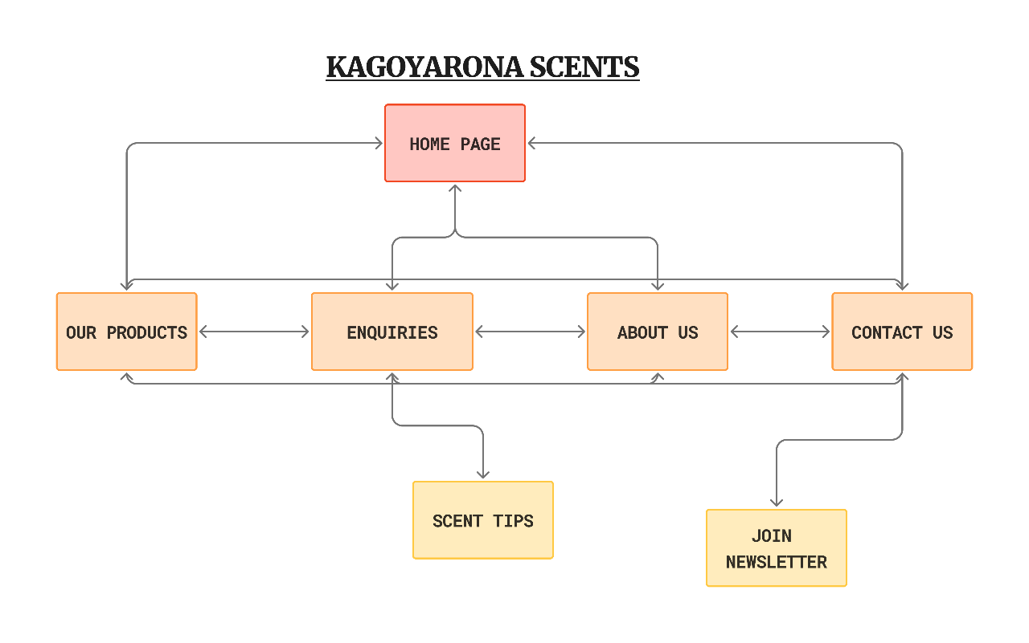

**Reference:**

Host Africa, “Domains.” *HOSTAFRICA*, Aug. 2022, <https://hostafrica.co.za/domains/>

Host Africa, “Web Hosting.” *HOSTAFRICA*, Aug. 2022, <https://hostafrica.co.za/web-hosting/>

Wholesale Diffusers, “Page Restricted.” *Wholesalediffusers.com*, 2025, <https://wholesalediffusers.com/>

Kagoyarona Scents, “Kagoyarona Scents (@Kagoyarona_scents_) • Instagram Photos and Videos.” *Instagram.com*, 2017, <https://www.instagram.com/kagoyarona_scents_?utm_source=ig_web_button_share_sheet&igsh=ZDNlZDc0MzIxNw==>, Accessed 27 Aug. 2025.

Kagoyarona Scents, *Facebook.com*, 2025, <https://www.facebook.com/profile.php?id=61573181644510>, Accessed 27 Aug. 2025.